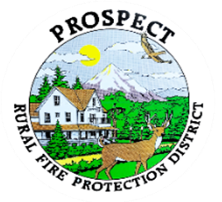

Agenda
Regular Board Meeting
September 21, 2026 at 6 pm
Prospect Library – Meeting Room

OUR MISSION is to preserve and protect life and property in our Upper Rogue community.

- Call to Order.
- Roll Call.
- Approval of Minutes.
- Emergency additions to the agenda.
- Financial Report.
- Chief’s Report.
- Station One construction project. (Update)
- Discussion regarding the future station (1st and Millcreek Drive).
- Hydrant and pump survey (Millcreek Drive)
- Public document/ info: Successes since the Levy Passed (Update)
- Public comment.
- Adjourn.
Public comment, limited to 3 minutes per speaker

Next Board of Directors meeting, 6:00 pm, October 19th, 2026
BOD agenda Items due by October 12 , 2026

