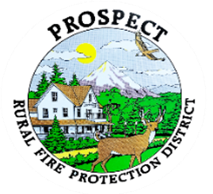

Agenda
Regular Board Meeting
September 15, 2025 at 7 pm
Prospect School - Media Center

OUR MISSION is to preserve and protect life and property in our Upper Rogue community.

- Call to Order.
- Roll Call.
- Approval of Minutes.
- Emergency additions to the Agenda.
- Financial Report.
- Chief’s Report.
- Seismic Retrofit Report
- Chiefs Evaluation; Goals from Chief and Board.
- Discussion of working session to address policy book.
What sections or section to be addressed?
Amount of time to be spent or goal to be reached?
- Public comment.
- Adjourn.

Public comment, limited to 3 minutes per speaker

Next Board of Directors meeting, 7:00 pm, October 20, 18, 2025
BOD agenda Items due by 13 October , 2025

