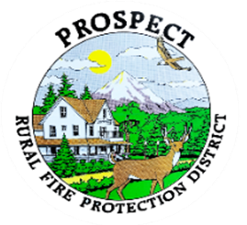

Agenda
Regular Board Meeting
January 23, 2026 at 7 pm
Prospect Library – Meeting Room

OUR MISSION is to preserve and protect life and property in our Upper Rogue community.

- Call to Order.
- Roll Call.
- Approval of Minutes.
- Emergency additions to the agenda.
- Financial Report. Results of audit.
- Chief’s Year in Review Report.
- Fill Hydrant Opportunity in The Cascade Gorge.
- Seismic Retrofit Report. Do we still need this one?
- Litigation lodged against department over copyright infringement. (Update to close the record?)
- Items for consideration (but not limited to) on the year’s calendar.
- Fire district map
- Maintenance policy
- Chief Evaluation
- Repair of hydrant system, Expansion of the system
- Start the process for a new station
- Discussion of working session. Do we wish to schedule one this month.
- Public comment.
- Adjourn.
Public comment, limited to 3 minutes per speaker

Next Board of Directors meeting, 7:00 pm, February 20, 2026
BOD agenda Items due by 6 February , 2026

