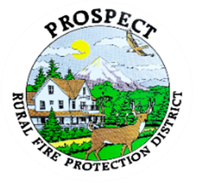
Agenda
Board Special Work Session
September 21, 2025 at 0100 pm
Crater Lake RV Park
46611 Hwy 62, Prospect

OUR MISSION is to preserve and protect life and property in our Upper Rogue community.

- Call to Order.
- Roll Call.
- Develop plan going forward to resolve the policy book.
- Public comment.
- Adjourn.

Public comment, limited to 3 minutes per speaker

