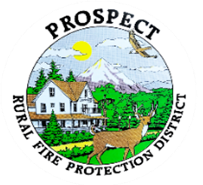

Agenda
Regular Board Meeting
February 20, 2026 at 7 pm
Prospect Library – Meeting Room

OUR MISSION is to preserve and protect life and property in our Upper Rogue community.

- Call to Order.
- Roll Call.
- Approval of Minutes.
- Emergency additions to the agenda.
- Special guest Dave Connor, He has requested to address the Board.
5 minutes requested.
- Financial Report.
- Chief’s Year in Review Report.
- Lions Park Contract.
- Fill Hydrant Opportunity in The Cascade Gorge.
- Litigation lodged against department over copyright infringement. (Update to close the record?)
- Discussion of working session. Chief Evaluation.
- Public comment.
- Adjourn.
Public comment, limited to 3 minutes per speaker

Next Board of Directors meeting, 7:00 pm, March 20, 2026
BOD agenda Items due by 6 March , 2026

