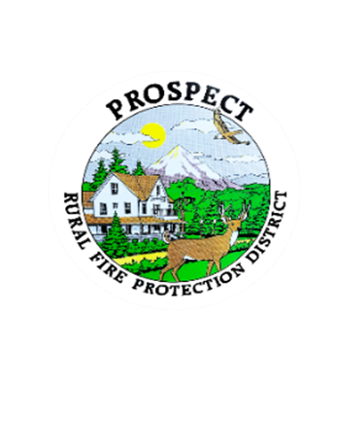 | Special Meeting Agenda  8-22-2022  @ Station 1- 276 Mill Creek Dr.

Meeting Opens
- Call to order
- Roll call
- Additions to agenda
- Approval of minutes

Additions to Agenda

Informational
- Reasons for meeting – Lon Stockabrand

Special Meeting Topics
- Fire Chief job description and duties discussion
- Book one of new policies discussion “Board Policies” (If time permits)

Public Comments

Next Meeting
Special Policy Meeting: 8-29-2022 @7pm @Station 1 – 276 Mill Creek Dr.

