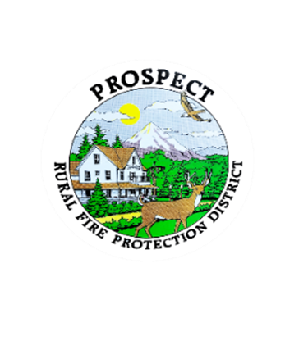

Agenda

Special Board Meeting

Work Session

November 7, 2024

7:00pm

Prospect Library

1. Call to Order
2. Roll Call
3. Review status of Policy and Procedure Manual
4. Review Fire Chief Hiring Documents
5. Review Levy Details, if time

The public is welcome to attend!