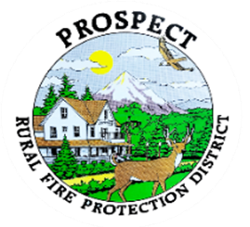

Agenda
Regular Board Meeting
April 17, 2026 at 7 pm
Prospect Library – Meeting Room

OUR MISSION is to preserve and protect life and property in our Upper Rogue community.

- Call to Order.
- Roll Call.
- Approval of Minutes.
- Emergency additions to the agenda.
- Financial Report.
- Chief’s Report. Tender update.
- Prospect Fire District goals and priorities Presentation and vote to adopt.
- Resolution regarding PPE replacement fund.
- Resolution regarding Equipment and vehicle fund.
- Resolution regarding Facilities fund
- Budget committee
- Fill Hydrant Opportunity in The Cascade Gorge. Update
- Discussion of working session.
- Public comment.
- Adjourn.
Public comment, limited to 3 minutes per speaker

Next Board of Directors meeting, 7:00 pm, May 15, 2026
BOD agenda Items due by 6 May , 2026

