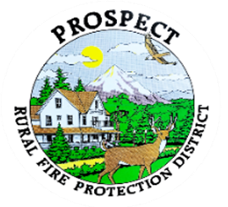

Agenda
Regular Board Meeting
June 15, 2026 at 7 pm
Prospect Library – Meeting Room

OUR MISSION is to preserve and protect life and property in our Upper Rogue community.

- Call to Order.
- Roll Call.
- Approval of Minutes.
- Emergency additions to the agenda.
- Financial Report.
- Chief’s Report.
- Budget committee update and next steps.
- Station One septic issue. (Update)
- Fill Hydrant Opportunity in The Cascade Gorge. (Update)
- Discussion of working session.
- Public comment.
- Adjourn.
Public comment, limited to 3 minutes per speaker

Next Board of Directors meeting, 7:00 pm, July 15 or 19, 2026
BOD agenda Items due by 8 July, 2026

