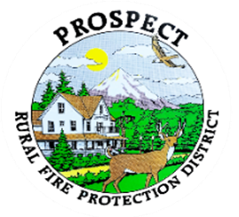

Agenda
Regular Board Meeting
May 15, 2026 at 7 pm
Prospect Library – Meeting Room

OUR MISSION is to preserve and protect life and property in our Upper Rogue community.

- Call to Order.
- Roll Call.
- Approval of Minutes.
- Emergency additions to the agenda.
- Financial Report.
Resolution 26-06 to Engage RWB&Co. for 2025-26 Audit.
Resolution 26-07 to replace Resolution 26-05 Transfer of Resources between funds for Water Tender
Resolution 26-08 Transfer of Resources between funds for Septic Repair
- Chief’s Report. Tender Final Report.
- Budget committee update and next steps.
- Volunteer Contract. Fire fighter vs. EMT. Obligation vs. training. Time? Let out options? Are we going to put this in the policy book or will this be a HR function?
- Station One septic issue.
- Fill Hydrant Opportunity in The Cascade Gorge. Update
- Discussion of working session and returning meetings to Mondays?
- Public comment.
- Adjourn.
Public comment, limited to 3 minutes per speaker

Next Board of Directors meeting, To Be Determined 7:00 pm, June 15 or 19, 2026
BOD agenda Items due by 8 June , 2026

