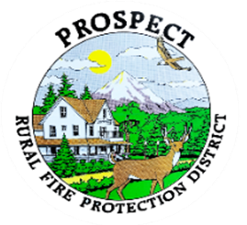

Agenda
Regular Board Meeting
October 20, 2025 at 7 pm
Prospect School - Media Center

OUR MISSION is to preserve and protect life and property in our Upper Rogue community.

- Call to Order.
- Roll Call.
- Approval of Minutes.
- Emergency additions to the agenda.
- Financial Report. Consideration of a resolution approving Audit Engagement Letter with BWB&Co..
- Chief’s Report. Requested update on tanker repair.
- Seismic Retrofit Report.
- Future projects preparation discussion.
- Discussion of new policy book format. Potential decision to adopt. Assignment of policies to individuals and working groups
- Discussion of working session to address policy book, 26 Oct 2025.
Further assignment of policies to individuals and working groups.
Review and edit products to be presented for adoption.
- Public comment.
- Adjourn.

Public comment, limited to 3 minutes per speaker

Next Board of Directors meeting, 7:00 pm, November 17, 2025
BOD agenda Items due by 7 October , 2025

