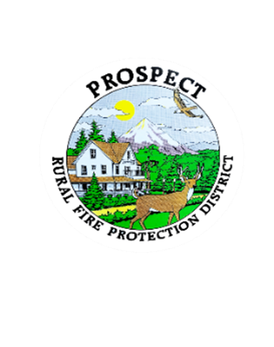

Agenda

Regular Board Meeting

August 25, 2025 at 7 pm

Prospect School - Media Center

**OUR MISSION** is to preserve and protect life and property in our Upper Rogue community.

1. Call to Order.
2. Roll Call.
3. Approval of Minutes.
4. Emergency additions to the Agenda.
5. Financial Report.
6. Chief’s Report.
7. Seismic Retrofit Report
8. Consideration of Fire Chiefs Evaluation Format.
9. Discussion of working session to address policy book.
10. Public comment.
11. Adjourn.

Public comment, limited to 3 minutes per speaker

Next Board of Directors meeting, 7:00 pm, September 18, 2025

BOD agenda Items due by 11 September , 2025