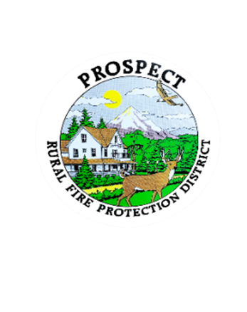**Prospect Rural Fire Protection District**

**Regular Board Meeting**

**Monday, April 17th,** 2023

Wigwam Building, Lion’s Park

Prospect, Oregon 97536

5:00 pm Board Training (for current board members)

Food and training provided by Jeff Griffin (SDIS)

**7:00 pm Regular Board Meeting (Open to the Public)**

1. Call to Order (Wayne Scrivens)

2. Roll Call (Rebecca Johnson)

3. Approval of March minutes

4. Swearing in new Board Member

5. President's Report (Wayne Scrivens)

6. Additions to Agenda?

**Old Business**

7. Report, adopt? Mission, Vision, Values statements (Rebecca Johnson)

8. Report, adopt? Bylaws Document (Rebecca Johnson)

**New Business**

9. Financial Report (Bob Jones)

10. Chief’s Report (Lyle Neville)

11. Public Comment (time permitting)

12. Next Meeting Monday, May 15th, 2023 7:00pm (location library meeting room?)

13. Adjourn