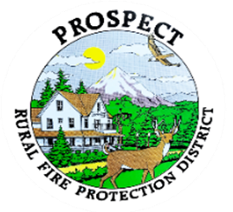

Agenda
Regular Board Meeting
November 17, 2025 at 7 pm
Prospect School - Media Center

OUR MISSION is to preserve and protect life and property in our Upper Rogue community.

- Call to Order.
- Roll Call.
- Approval of Minutes.
- Emergency additions to the agenda.
- Financial Report.
- Chief’s Report. Requested update on tanker repair.
- Seismic Retrofit Report.
- Litigation lodged against department over copyright infringement.
- Volunteer appreciation Dinner.
- Fire district map. Discussion over redefining the current area of responsibility.
- Maintenance policy and procedures discussion.
Safety impact. Information from the Chief. Plans moving forward. Do we need to implement an on-the-spot policy change?
- Discussion of new policy book format. Consideration of policy book cover (Presentation of options). Potential decision to adopt.
- Discussion of working session. Do we wish to schedule one this month.
- Public comment.
- Adjourn.

Public comment, limited to 3 minutes per speaker

Next Board of Directors meeting, 7:00 pm, November 17, 2025
BOD agenda Items due by 7 October , 2025

