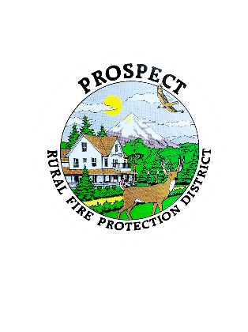

Prospect Rural Fire Protection District

P.O. Box 32, Prospect, OR 97536

**REGULAR MEETING AGENDA**

Monday, January 17st, 2022

* Call to order
* Roll Call
* Additions to the agenda
* Minutes of Novemeber meeting
* Communications
* Financial Report
* Deputy Fire Chief Report

OLD BUSINESS

* Grants
* Selling surplus vehicles
* Annexation requests
* Awards dinner discussion

NEW BUSINESS

* Tshirts
* Future Junior Fire Fighter Program
* New board secretary

Public Comments

Next meeting: February 18th, 2022