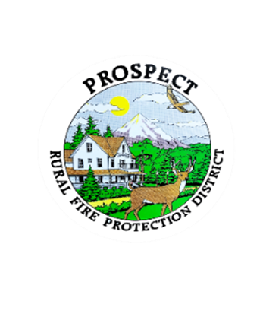

Agenda

Special Board Meeting

Work Session

November 14, 2024

7:00pm

Prospect Library

1. Call to Order
2. Roll Call
3. Work on Fire Chief Job Description
4. Begin review of Policy Book 2

The public is welcome to attend!