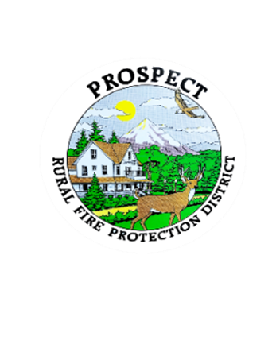

Agenda

Regular Board Meeting

September 16, 2024, at 7pm

Prospect School - Media Center

1. Call to Order (Karen Wickman)

2. Roll Call

3. Approval of August Minutes (Karen Wickman)

4. Emergency additions to the Agenda.

5. Financial Report (Bob Jones)

6. Chief’s Report (Lyle Neville)

7. Levy update (Melissa Taylor)

8. Fire Chief Annual Evaluation (Clay Thomas) 9. Goals, Policies and Procedures. (Karen Wickman)

10. Complete the corrections to Book One of Policies and Procedures and continue with Book Two. (Joyce Dierking)

11. Public comment, limited to 3 minutes per speaker.

12. Adjourn

Next Board of Directors meeting, 7:00pm Sept. 16, 2024

BOD agenda Items due by August 31, 2024